2022/2023

Introduction

Council’s Community Workshops Program provides community groups with the opportunity to undertake an online course targeted to improve the group’s ability to apply for grant funding and improve daily operations. Successful applicants will undertake an online course where upon successful completion they will be paid their course registration fee. Workshops are aimed at enabling the community to function cohesively and to build grant application skills.

Purpose of Workshops

Three online courses will be made available for not-for-profit community organisations to undertake learnings which will benefit them in their ability to function and flourish. Courses include:

- Step in, Step up - Everything a New Community Board Member Needs to Know. If you’ve recently joined a not-for-profit community board or committee, or you’re thinking of joining one, or if it’s your role to ensure new board members get a good induction, this is the course for you. The course will take you through the legal and ethical responsibilities of a not-for-profit board member and give you all the tools you need to get up to speed quickly and start contributing immediately.
- WTF – Where’s the Funding? - Fundraising is the lifeblood of most community organisations, yet it’s an often-neglected task. Most organisations draw the majority of their income from just one or two sources. That’s a dangerous strategy. If one of those sources dries up, you could quickly face a budget black hole. This course is designed for grassroots fundraisers. It will help participants identify all the many sources of income available to their organisation and give them confidence to start drawing from each of them. The result? Fewer burnt-out volunteers, more successful events, a bigger donor database, and ultimately a stronger, healthier, more sustainable community group.
- Win More Grants - Around $80 billion is given out in grants across Australia each year. Is your organisation getting its share? This course is designed for grassroots community groups that want to find out where to find grants and how to win them. With just a bit of know-how and some newfound confidence you’ll go from a grants novice to a grants go-getter!

Community Groups will be required to apply for a position in the courses due to the limited availability. Council will assess applications to ensure that the community group meets eligibility criteria. Applicants are not discouraged from applying to participate in multiple courses however higher priority will be given to those who either have only applied for one course or have advised a particular course is their highest preference.
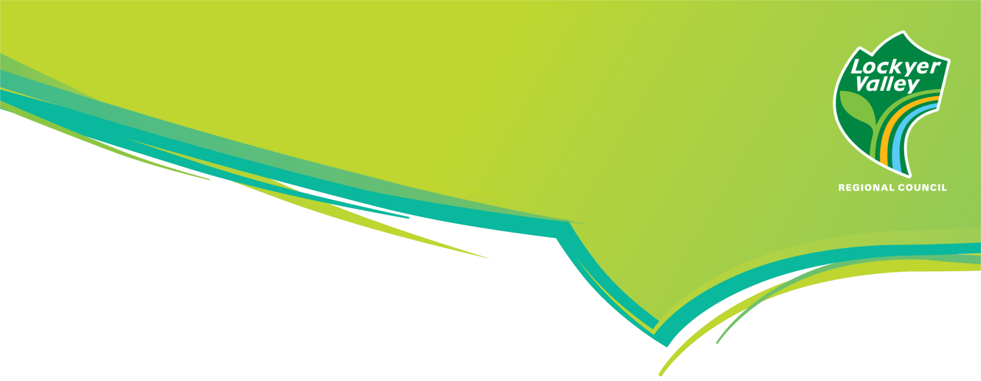

COMMUNITY

WORKSHOPS PROGRAM

Timetable for 2022/2023 Workshop Program
Application Open | July 2022
Application Close | March 2023
Application Assessment | Within 2 weeks of submission
Notifying Applicants | Within 2 weeks of submission
Workshop dates | Step In, Step Up | 2022/23 Financial Year
- | WTF – Where’s the Funding | 2022/23 Financial Year
- | Win More Grants | 2022/23 Financial Year
Grant Acquittal | Within 2 months post workshop

Eligibility for Community Workshops Program

Not‐for‐profit community organisations that:
- Operate within the Lockyer Valley local government area or can demonstrate the projects, activities or events will benefit residents of the Lockyer Valley local government area
- Have appropriate insurance and adhere to sound workplace health and safety practices
- Are able to demonstrate viability
- Have no debt to council, or have entered into scheduled payment arrangements with council which are being met
- Have met acquittal conditions for previous council grants

If a community organisation is not a legal not‐for‐profit entity or recognised by the Australian Taxation Office as a not‐for‐profit type, the application must be auspice and administered by such a group. Applicants may submit only one grant application per round.

Ineligibility for Community Workshops Program

The following are not eligible for participation:
- Businesses
- Individuals who are not part of not-for-profit community groups

Full information regarding Community Workshops

Council will only reimburse costs for applicants approved through this process. The number of places per course is limited and Council will share the opportunity across as many community organisations as possible. Council will assess applications to ensure that the community group meets eligibility criteria. While we encourage community groups to apply for several members to complete all 3 courses, approval for each course is subject to ongoing budgets and an equitable opportunity for all community groups. For further information regarding Council Community Workshops Program please speak with Lockyer Valley Regional Council’s Community Engagement and Communications Team on 1300 005 872 or at cateam@lvrc.qld.gov.au

